(Approx. 466 words)

The Winter 2019 Windows 10 Update
By Rosita Herrick, Forum Moderator, Sarasota Technology Users Group, FL
January 2019 issue, The STUG Monitor
www.thestug.org
hrosita (at) aol.com

By now, some of you have already updated to the current version of Windows 10 and, if not, you should soon receive the update on your computer. Once your PC is updated, the Windows version will show as Version 1809 (OS Build 17763.134)

Listed below are five additions that come with this update and that I found useful for the average user

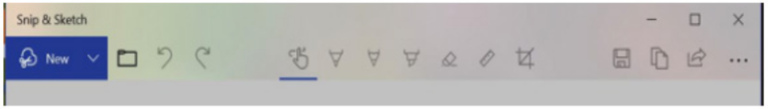
- A new Snip and Sketch app (that will eventually replace the Snipping Tool) was added that supports the use of a stylus and the option to start it with the shortcut Win key + Shift + S.

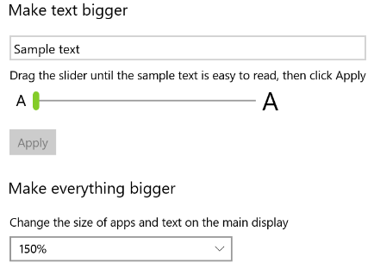
- Change System font size
Using a new slider, it is easy to adjust the font size for the Start menu, titles, message boxes, and tool tips for all apps. Select Settings and enter Make text bigger in the search box. To increase the size of text on your screen, adjust the slider under Make text bigger. To make everything larger, including images and apps, choose an option from the dropdown menu under Make everything bigger.

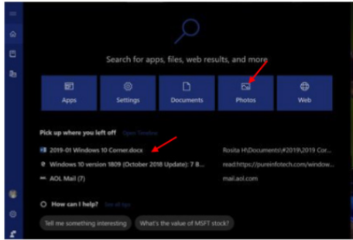
- Cortana
The display that pops up when the user clicks on the Cortana search box has changed. As you can see below, you can click on any of the blue boxes to limit where Cortana looks for the search argument. Also, below the boxes the links displayed are the items the user had worked on previously. As you can see, the first item is the title of the Word document that I am preparing for the Monitor, so I can pick it up later if I have to stop at any time.

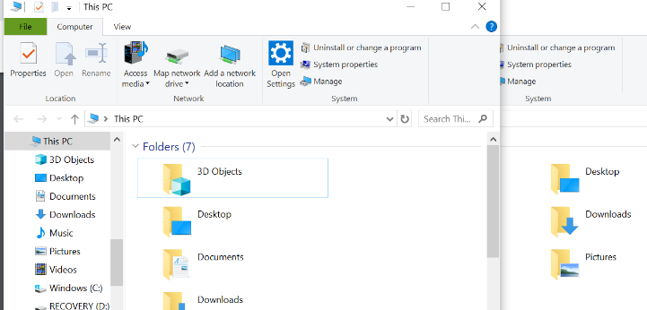
- There is now a new keyboard short cut to start a second screen of an active app. The shortcut is Ctrl + N. For example, in the picture below I have an open File Explorer screen . Pressing the shortcut Ctrl + N gave me a second screen. This is very handy when you want to copy or move either a file or folder from one place to the other. The pages can be separated by clicking on the blue bar of the active screen and dragging the page.

- The new Cloud-powered clipboard introduces a new interface (which you can invoke using the Windows key + V shortcut) to view your history, paste previous content, and pin items that you may need to paste in the daily basis.

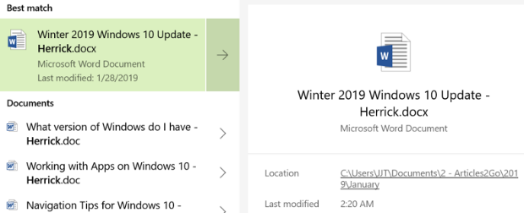
- Search experience
Searching for an app or document, the right pane will now show common actions, including options to run an app as an administrator, file information, such as path and the last time the document was modified, and more.

